Fundraising

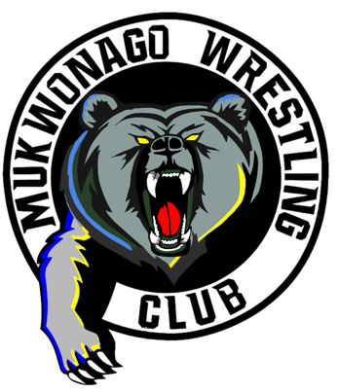
We have two fundraising events for the club every year to fund the club expenses, selling Racine Kringle’s/Grizzly Pizzas and our Mukwonago wrestling tournament. Each family can earn Club apparel through these sales. Each item type is worth one point. So, selling 50 items is the goal.

Every 50 points earns you a prize.
Racine Kringle 1 points

Grizzly Pizza 1 points

40 points will refund your $40 buyout paid at signup.

Selling:
If your customers write a check, have them make the checkout to “you”.
At pick-up, please write a single check to “Mukwonago Wrestling Club”,
Tips:
- Racine Kringles is a great treat for your holiday friends/guests.
- Collect money right away on the initial sale, makes delivery easier.
- Get selling right away and meet your goal early.

Enter Sales on Member site: deadline– Nov 17th

Please do NOT turn in the money; all money is due upon pick-up.

Need Your Help – Saturday Dec.16th Making Grizzly Pizzas at Big Bend Elementary gym
- 2 shifts Saturday 7am to 11am & 11am to completion.

Pick-Up Sunday morning Dec. 0th. At the Big Bend Parking lot
Please plan on picking them up between 8:15am - 10:00 am on Sunday.
Please write a single check to “Mukwonago Wrestling Club”, If you bring Cash, please bring exact amount. We also accept Venmo.

If you can’t pick them up that day, please notify Paul Ksobiech President@mukwonagowrestlingclub.com ahead of time, to make arrangements.

Our web site www.mukwonagowrestlingclub.com has a copy of the sale forms, if you need extras.

