Mukwonago Wrestling Club Singlet Policy
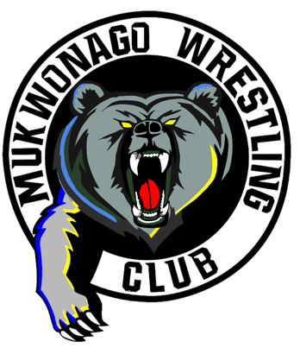
The Mukwonago Wrestling Club members, board members and coaches are very proud of this organization, its’ wrestlers, and their accomplishments. How we conduct ourselves on and off the mat reflects on the participant, our Club, and the community of Mukwonago. We always want to have the respect and status as one of the best clubs in the state. That is why we provide our members some of the coolest singlets in the state.

Borrowing Singlet Policy
The Club apparel store does provide parents the ability to purchase a MWC singlet with name on back. However, we know kids grow fast and can quickly outgrow the singlet every year, therefore the Mukwonago Wrestling Club borrows Mukwonago Grizzly Singlets free of charge. We require a $100 Deposit in the form of a check, refunded upon return. Club designated singlets provide our wrestlers a sense of membership and club unity. It also gives the coaches and membership the ability to locate our Mukwonago Club wrestlers in order to coach and encourage them during their matches.

When you are done competing for the year, get the Singlet back to us ASAP, do not make us chase you down for its return 😊…

How do you check out a singlet ?
Answer: 1) Pass the skills test (if required)
2) Provide a deposit check

In order to better prepare and ensure our Club wrestlers have the base level of knowledge before going into a match, we require each wrestler to pass a minimum skills test before wrestling in a tournament. This does not mean they are necessarily ready to compete but at least they have been able to demonstrate basics skills. We have developed a ladder of skills by grade. Before beginning to wrestle in tournaments, this skill test will provide the child assurance and help the coaches identify where to focus. We have had unprepared wrestlers in the past quit the sport, after entering into tournament competition too soon. Wrestling is a very challenging sport both mentally and physical. The younger the child the higher possibility the intensity of a match can turn them off. Almost as bad, is a child winning on poor technique, therefore discouraging the development of proper skills.

- All Mukwonago Club wrestlers are required to wear the Mukwonago Club singlet at Club supported folk style tournaments The schedule defines club tournaments during the season.
- For Freestyle/Greco we have a set of reversible MWC singlets, Red on one side, Blue on the other, Ready for Freestyle / Greco season in April.

