Track Wrestling Registration
www.trackwrestling.com is the site used to find and register for wrestling tournaments. Here are the basics for searching and registering for a wrestling tournament.
Searching
We will start with searching for a tournament. Although the site has many menus and options there is a simple way to search for a tournament.
- Click on the “Browse” options across the top.
- You will see “Tournaments” and click on it.
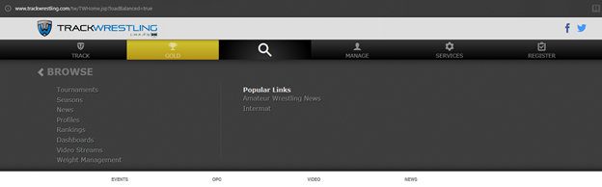

- This will bring a list of all tournaments up.
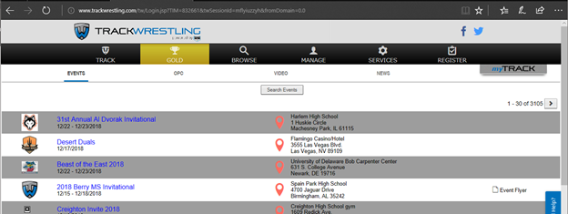
- These tournaments are from all over the US and will be very hard to go through. To shorten the list, you will want to search. Click the “Search Events”.
- This will bring up a list of all the search items available. As you get better at searching you may expand to filter it down further. 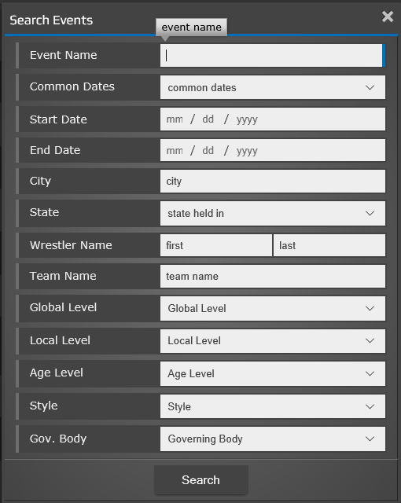
- But for your first few you will want to filter on State, City (if you know where the tournament is), and the date of the tournament. Once you have those filled in you will click the “Search” button.
- This will bring up a much shorter list to allow you to find your tournaments easier.
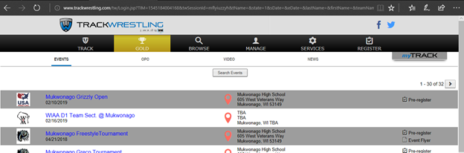
- In this list you will find your tournament. When you find your tournament, you will be using the links on the far right “Pre-Register”, “Event Flyer”, or “Website” to gather information and register for the tournament. Not all tournaments will have all options, and if there is not a Pre-register link then please see the practice table.
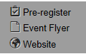

Registering for a tournament
After you have identified what tournament you would like to attend and found it on trackwrestling you are ready to register for the tournament. This is done through track wrestling.
- Find your tournament using the steps from the previous section.
- Click the “Pre-Register” link.
- This will take you to the Registration/Sign in Screen.
- If you have created an account you can sign in here. If you do not wish to create an account you can click the “Continue as guest” orange button.
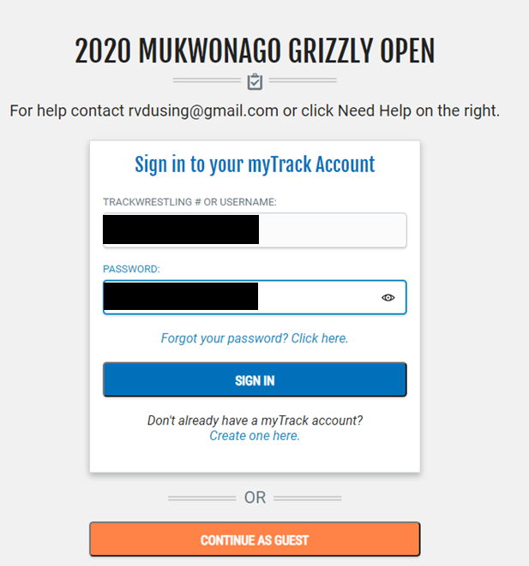
- Once you click “Continue as Guest” you will see the tournament and an orange “Register Now” Button.
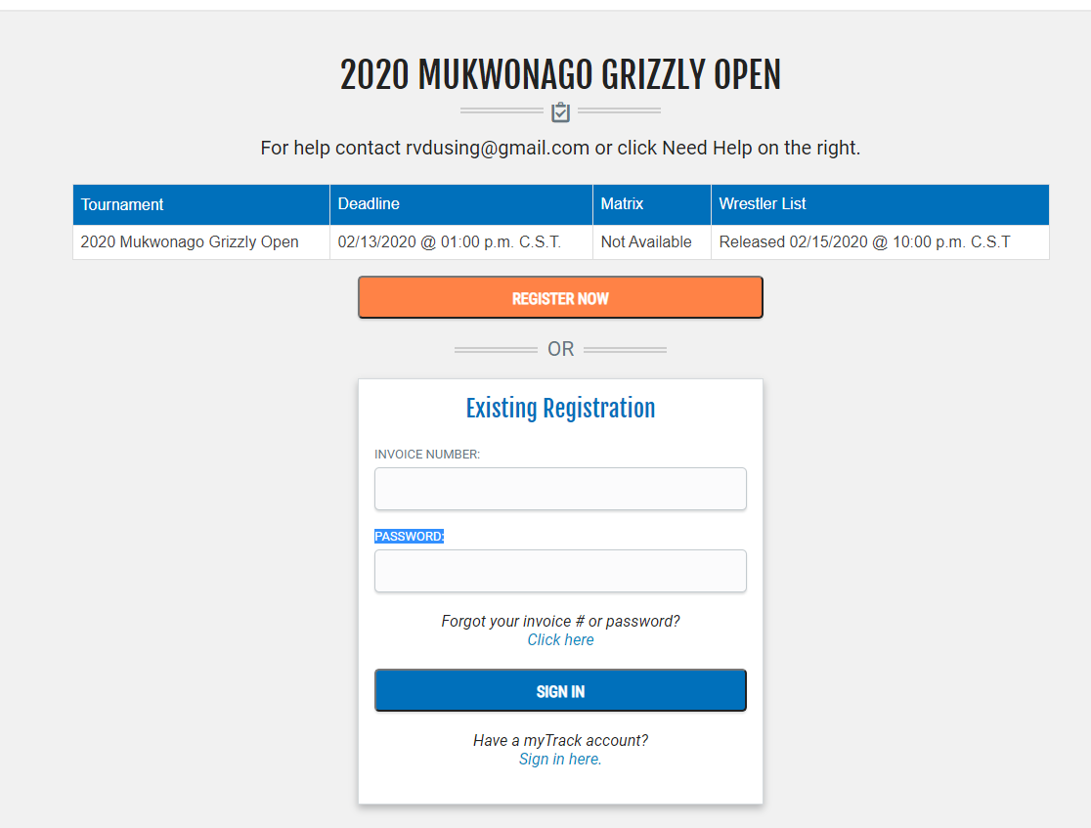
- When you click the Register Now button you may be prompted for a user creation. (unless you have already signed in or created an account).
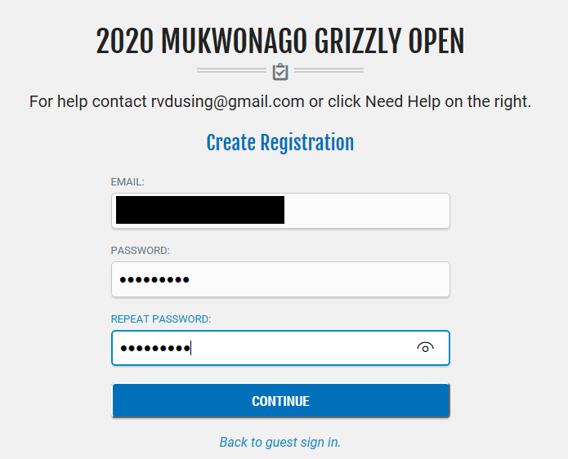
- You have an account you will see the Add Wrestler screen. If you have signed in you may already see your wrestling listed here. If you wrestler is already in the list
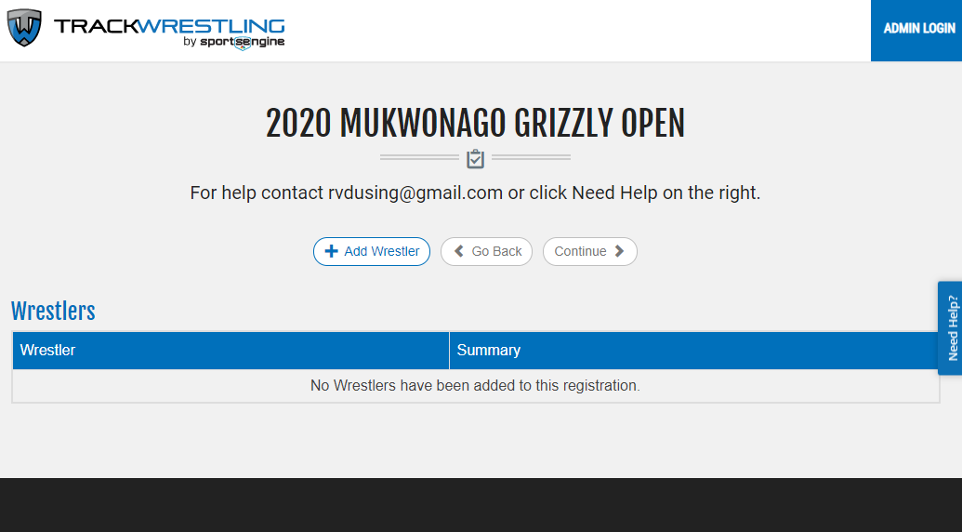
- To add your wrestler you will click the “Add Wrestler” button which will prompt your for a “USA Wrestling ID”. This ID is the 6 digit 902### number from your red USA Wrestling card received when signing in.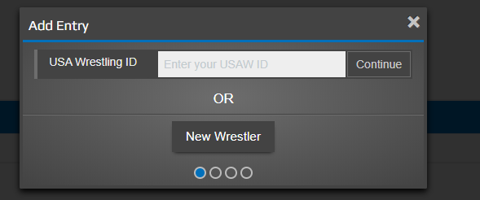
- After putting the number in you can click the “Continue” button next to the number.
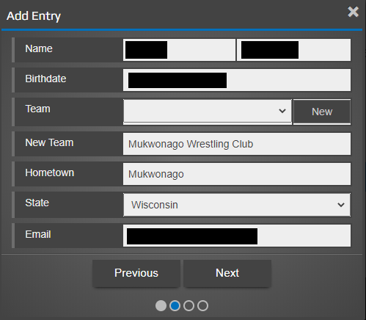
- If done correctly you should see your child’s information already filed out. Fill in any additional fields and click next.
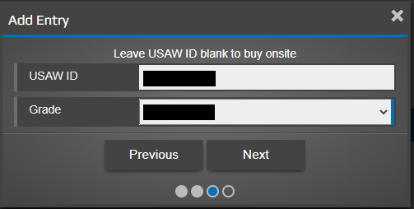
- It will once again ask for the USA number which should already be filled in and your childs grade. Fill it in and click “Next”
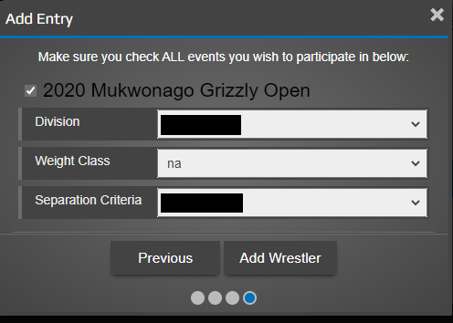
- You will make sure you have the tournament you want to attend checked at the top, fill out the division (year of birth), weight, and Separation Criteria. The weight is not always available to be filled in if the tournament requires a on official weigh-in. Also, please be as honest in the Separation Criteria as you can. If you have questions on where your son should be placed please ask a coach or table worker and we can assist to the best of our ability.
- Once that is filled out you should click “Add Wrestler”. This will take you to the review screen.
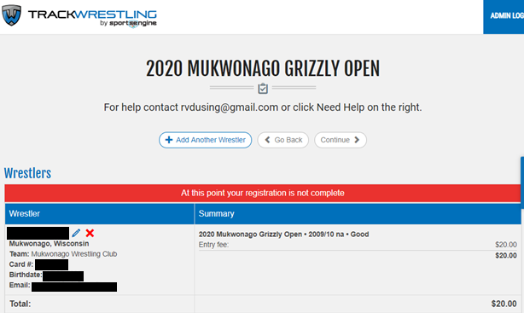
- Once you are at this point you will click “Continue >”.
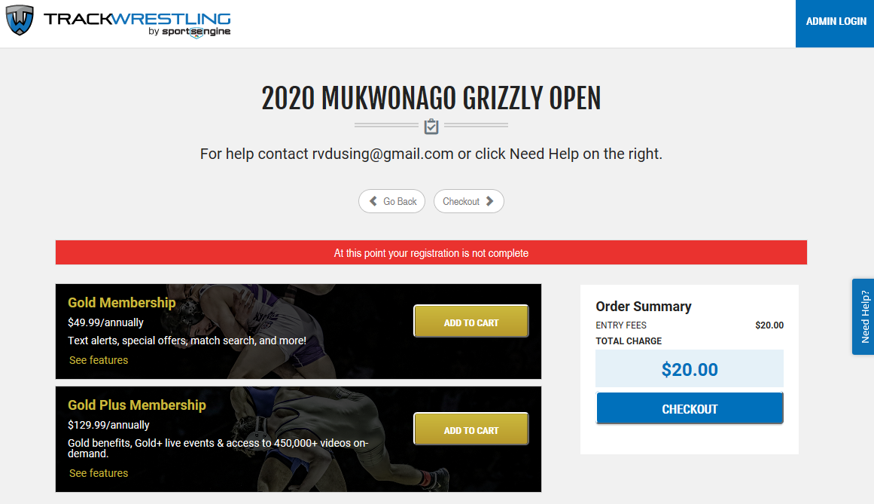
- Now click “Checkout”. You will fill in your payment information and follow the instructions. At that point your child is registered. If you have questions, once again, we always have board members and coaches available for questions.

